
COMMUNITY TRANSLATION – ADVANCED GUIDELINES

SPORTS INTERACTIVE
ADVANCED GUIDELINES FOR COMMUNITY TRANSLATION
The Advanced Guidelines for Community Translation cover specific areas of translating Football Manager using LTF and FMF files in more detail. Areas covered include understanding Strings, Variables, formatting within Strings, Genitive and Possessive instances, Feminisation, Genders, Ordinal and Cardinal numbers, Date Variables, Complex Variables, giving Genders to Complex Variables, giving genders to phrases that appear within variables, translating entities using the Football Manager 2023 Editor and publishing FMF Translations to the Steam Workshop.

STRINGS

- As discussed above a “string” is a line of text. It can range in length from just one character to a complete set of multiple sentences.
- Each string has its own unique ID number. These are used by the game to ensure the correct string appears in the correct place.
- Here’s an example of a basic string with a French translation:

KEY-427652: This team are now officially the most improved club![COMMENT: in-game social media string, please feel free to translate 'informally' but also keep it short, there's no strict character limit but they're meant to be succinct]
STR-1: C'est officiel, ce club est celui ayant le plus progressé!

- The string can be broken down into four parts: ID, Text, Comment and Translation
  - ID: “KEY-427652” - this is the string’s ID. The game uses this to identify the string and place it correctly within Football Manager.
  - TEXT: “This team are now officially the most improved club!” - this is the English version of this string. The text here is what appears in game. It’s also the text to translate.
  - COMMENT: “[COMMENT: in-game social media string, please feel free to translate 'informally' but also keep it short, there's no strict character limit but they're meant to be succinct]” - the comment describes and explains the string and gives useful tips to coders and translators as to what the string is about and sometimes where in-game it might appear. The comment explains that fact and offers some advice on how to translate it appropriately for the context in which it will appear.
  - TRANSLATION: “STR-1: C'est officiel, ce club est celui ayant le plus progressé!“ – this is the actual translation. In this example we’ve translated the string into French. Note your translation must always be preceded by “STR-1: ” (with the space) and there is no need to translate the comment.

- Note that in a few cases the “example.ltf” already contains “Translations” in the “STR-1:” section. These are English to English “fixes” where the LTF system has been used internally to change, update or correct existing strings. When creating translations here make sure to translate the “correct” text which follows the “STR-1: ” section, overwriting it with your desired target text.
- Some strings are more complex and may contain variables and/or formatting as discussed below.

VARIABLES

- A “variable” is a code container within a string that will appear in-game as something specific, for example: clubs, people, nations, competitions, injuries etc.
- Variables are split into several parts, some of these parts must stay the same in your translation in order for the code to work correctly, other parts are more flexible and can be changed in a translation based on the required effect.

- Here’s an example of a basic variable:

[%position#1-short2]

- The table below shows the different parts of the variable and a description of what each part does.

Variable Part | Description
[ | opening bracket – this must be included
% | indicates a variable to the code and must be included
type (e.g. position) | Indicates type of variable and must be included. There are many different variable types in Football Manager. Most are self-explanatory. Note that [%string] type variables can contain many different types of text, look in the COMMENT for an explanation when these are encountered.
#n (e.g. #2) | must be included and number must match the original English.
-variableproperty (e.g. -short) | This is optional and is not always used. It can be replaced by any of the other “property settings” for that particular type. As you become familiar with the many variables within Football Manager you will encounter more and more property types.
n (optional number qualifier) | This number indicates which version of the type is needed in the translated language (usually due to case differences). This is pulled from the database and is optional and only needed in some languages. If there is no property you still need to add the dash(-) e.g. [%position#1-2]
] | Closing bracket – this must be included

- As mentioned above sometimes it is appropriate to interchange variables with the same meaning.
- For example, the phrase “[%nation#1-nationality] players” (e.g. “English Players” – as it would appear in-game) could instead be translated as “Players from [%nation#1]” (e.g. Players from England)
- This is up to the translator, in some languages using the noun and not the adjective makes more sense.

FORMATTING WITHIN STRINGS

- "/n": this indicates a carriage return (new line) within a string. When these appear please always include them in your translations in the same place they appear in the source text (also use these in non-Latin script languages to indicate a carriage return (paragraph mark).
- A double “/n/n” means two paragraph marks
- If you need to change a variable name starting with an upper case to a lower case simply use {lower} in front of the variable (e.g. {lower}[%stage]
- To change from lower case to upper case use {upper}.
- It is possible to use simple styles within strings displayed that are displayed as LABELs or TEXTs. The format is similar to BBCode used on forums:
- Instead of [ ] type brackets these can now be used in translations with the pipe '|' syntax.
  - Bold: This |b|text|/b| will be displayed partially |b|bolded|/b|
  - Italic: This |i|text|/i| will be have some |i|italic|/i| bits
  - Underlined: This should be |u|underlined|/u|
  - Coloured: Some |c:red|red text|/c|
  - Change spec (this should be used with care): Changing spec allows even the |x:title|font-size|/x| to vary
  - Used in combinations: This |I|string |b|shows|/i| |c:green|how different|/b| styles|/c| can be combined and nested

GENITIVE / POSSESSIVE

- For genitive or possessive instances, for example "Everton's finances" we use “{s}” in English.
- At present it’s not possible to hardcode this for new languages so be aware your translation may be limited in this regard.

FEMINSATION

- In order to provide appropriate strings for female users and the many females that appear within Football Manager as non-players (manager, chairman, coach, physio, director etc.) every string that references either the human user or a female in a non-playing role can be translated to ensure appropriate language is used (i.e. “she”, “her”, different personal pronouns, verbs and/or adjectives when a language calls for them)
- Strings of this kind take the following format:
  - Each string is treated as a master key.
  - Wherever male/female versions are needed these versions will become sub-keys of the master key.
- There is no need in these instances to translate the master Key.
- To illustrate this, take a look at the strings/translations below and notice the different pronoun variables (“[%male#2-he] -> il:” and “[%female#2-she] -> elle”):
Master Key

KEY-386578: {upper}[%nation#1-nationality] investor [%person#2] says [%person#2-he] would make [%cash#2-roundlarge] available for new players if [%person#2-his] takeover plans for [%team#1] are successful.\n\n{upper}[%person#2-surname] is reportedly looking to buy out the club's owners for around [%cash#1-roundlarge].[COMMENT: board_takeover_news_item; BOARD_TAKEOVER_TYPE_RICH_INDIVIDUAL, use top ten matches, ID 276897]
KEY-386578-M: {upper}[%nation#1-nationality] investor [%male#2] says [%male#2-he] would make [%cash#2-roundlarge] available for new players if [%male#2-his] takeover plans for [%team#1] are successful.\n\n{upper}[%male#2-surname] is reportedly looking to buy out the club's owners for around [%cash#1-roundlarge].[COMMENT: board_takeover_news_item; BOARD_TAKEOVER_TYPE_RICH_INDIVIDUAL, use top ten matches, ID 276897]
Male sub-key
STR-1: L'investisseur [%nation#1-nationality1] [%male#2] a indiqué qu'il mettrait [%cash#2-roundlarge] à la disposition du club pour acheter de nouveaux joueurs si son plan de reprise {de la}[%team#1] était accepté.\n\nSelon certaines sources, [%male#2-surname] chercherait à racheter la part des propriétaires du club pour environ [%cash#1-roundlarge].
KEY-386578-F: {upper}[%nation#1-nationality] investor [%female#2] says [%female#2-she] would make [%cash#2-roundlarge] available for new players if [%female#2-her] takeover plans for [%team#1] are successful.\n\n{upper}[%female#2-surname] is reportedly looking to buy out the club's owners for around [%cash#1-roundlarge].[COMMENT: board_takeover_news_item; BOARD_TAKEOVER_TYPE_RICH_INDIVIDUAL, use top ten matches, ID 276897]
Female sub-key

STR-1: L'investisseur [%nation#1-nationality1] [%female#2] a indiqué qu'elle mettrait [%cash#2-roundlarge] à la disposition du club pour acheter de nouveaux joueurs si son plan de reprise {de la}[%team#1] était accepté.\n\nSelon certaines sources, [%female#2-surname] chercherait à racheter la part des propriétaires du club pour environ [%cash#1-roundlarge].

KEY-234963: \n\nAs yet the media seem unwilling to speculate as to who will replace [%person#1-surname] at [%stadium#1].[COMMENT - manager_news_items; speculation on next manager]
Master Key

KEY-234963-M: \n\nAs yet the media seem unwilling to speculate as to who will replace [%male#1-surname] at [%stadium#1].[COMMENT - manager_news_items; speculation on next manager]
Male sub-key
STR-1: \n\nPour l'instant les médias semblent se refuser au petit jeu des pronostics quant à qui remplacera [%male#1-surname] {à stadium}[%stadium#1].
KEY-234963-F: \n\nAs yet the media seem unwilling to speculate as to who will replace [%female#1-surname] at [%stadium#1].[COMMENT - manager_news_items; speculation on next manager]
Female sub-key

STR-1: \n\nPour l'instant les médias semblent se refuser au petit jeu des pronostics quant à qui remplacera [%female#1-surname] {à stadium}[%stadium#1].

- As a string can contain more than one non-player there will be an exponential number of sub-keys required. For example, if one non-player is involved there are two sub-strings, one for a male and one for a female. If two non-players are involved then it might be two male, one male and one female, one female and one male or two females, this would require four strings. If three different non-players are involved within one string, you will consequently need 8 sub-keys, 4 will have 16 (the system is limited to 16 sub keys for 4 non-players. Note there are currently only 5 such strings currently).
- There is also the possibility of specifying that the default male translation (-M, -MM, -MMM or –MMMM) can be used for all versions by simply leaving the other versions blank. This will save needless translation time.
- Here is an example of an untranslated string with four different non-players and all the variations/sub-keys this may require:

KEY-243673: - The club's administrative staff indicate that this proposal will be faxed to the managers of every club, with the exception of [%person#1], [%person#2], [%person#3] and [%person#4]. Should you wish to offer this player to those managers then you will have to add them to the proposal. You will be contacted in the near future should there be any interest.[COMMENT - comment on transfer offer screen when player is being offered to other clubs]
KEY-243673-MMMM: - The club's administrative staff indicate that this proposal will be faxed to the managers of every club, with the exception of [%male#1], [%male#2], [%male#3] and [%male#4]. Should you wish to offer this player to those managers then you will have to add them to the proposal. You will be contacted in the near future should there be any interest.[COMMENT - comment on transfer offer screen when player is being offered to other clubs]
STR-1:
KEY-243673-MMMF: - The club's administrative staff indicate that this proposal will be faxed to the managers of every club, with the exception of [%male#1], [%male#2], [%male#3] and [%female#4]. Should you wish to offer this player to those managers then you will have to add them to the proposal. You will be contacted in the near future should there be any interest.[COMMENT - comment on transfer offer screen when player is being offered to other clubs]
STR-1:
KEY-243673-MMFM: - The club's administrative staff indicate that this proposal will be faxed to the managers of every club, with the exception of [%male#1], [%male#2], [%female#3] and [%male#4]. Should you wish to offer this player to those managers then you will have to add them to the proposal. You will be contacted in the near future should there be any interest.[COMMENT - comment on transfer offer screen when player is being offered to other clubs]
STR-1:
KEY-243673-MMFF: - The club's administrative staff indicate that this proposal will be faxed to the managers of every club, with the exception of [%male#1], [%male#2], [%female#3] and [%female#4]. Should you wish to offer this player to those managers then you will have to add them to the proposal. You will be contacted in the near future should there be any interest.[COMMENT - comment on transfer offer screen when player is being offered to other clubs]
STR-1:
KEY-243673-MFMM: - The club's administrative staff indicate that this proposal will be faxed to the managers of every club, with the exception of [%male#1], [%female#2], [%male#3] and [%male#4]. Should you wish to offer this player to those managers then you will have to add them to the proposal. You will be contacted in the near future should there be any interest.[COMMENT - comment on transfer offer screen when player is being offered to other clubs]
STR-1:
KEY-243673-MFMF: - The club's administrative staff indicate that this proposal will be faxed to the managers of every club, with the exception of [%male#1], [%female#2], [%male#3] and [%female#4]. Should you wish to offer this player to those managers then you will have to add them to the proposal. You will be contacted in the near future should there be any interest.[COMMENT - comment on transfer offer screen when player is being offered to other clubs]
STR-1:
KEY-243673-MFFM: - The club's administrative staff indicate that this proposal will be faxed to the managers of every club, with the exception of [%male#1], [%female#2], [%female#3] and [%male#4]. Should you wish to offer this player to those managers then you will have to add them to the proposal. You will be contacted in the near future should there be any interest.[COMMENT - comment on transfer offer screen when player is being offered to other clubs]
STR-1:
KEY-243673-MFFF: - The club's administrative staff indicate that this proposal will be faxed to the managers of every club, with the exception of [%male#1], [%female#2], [%female#3] and [%female#4]. Should you wish to offer this player to those managers then you will have to add them to the proposal. You will be contacted in the near future should there be any interest.[COMMENT - comment on transfer offer screen when player is being offered to other clubs]
STR-1:
KEY-243673-FMMM: - The club's administrative staff indicate that this proposal will be faxed to the managers of every club, with the exception of [%female#1], [%male#2], [%male#3] and [%male#4]. Should you wish to offer this player to those managers then you will have to add them to the proposal. You will be contacted in the near future should there be any interest.[COMMENT - comment on transfer offer screen when player is being offered to other clubs]
STR-1:
KEY-243673-FMMF: - The club's administrative staff indicate that this proposal will be faxed to the managers of every club, with the exception of [%female#1], [%male#2], [%male#3] and [%female#4]. Should you wish to offer this player to those managers then you will have to add them to the proposal. You will be contacted in the near future should there be any interest.[COMMENT - comment on transfer offer screen when player is being offered to other clubs]
STR-1:
KEY-243673-FMFM: - The club's administrative staff indicate that this proposal will be faxed to the managers of every club, with the exception of [%female#1], [%male#2], [%female#3] and [%male#4]. Should you wish to offer this player to those managers then you will have to add them to the proposal. You will be contacted in the near future should there be any interest.[COMMENT - comment on transfer offer screen when player is being offered to other clubs]
STR-1:
KEY-243673-FMFF: - The club's administrative staff indicate that this proposal will be faxed to the managers of every club, with the exception of [%female#1], [%male#2], [%female#3] and [%female#4]. Should you wish to offer this player to those managers then you will have to add them to the proposal. You will be contacted in the near future should there be any interest.[COMMENT - comment on transfer offer screen when player is being offered to other clubs]
STR-1:
KEY-243673-FFMM: - The club's administrative staff indicate that this proposal will be faxed to the managers of every club, with the exception of [%female#1], [%female#2], [%male#3] and [%male#4]. Should you wish to offer this player to those managers then you will have to add them to the proposal. You will be contacted in the near future should there be any interest.[COMMENT - comment on transfer offer screen when player is being offered to other clubs]
STR-1:
KEY-243673-FFMF: - The club's administrative staff indicate that this proposal will be faxed to the managers of every club, with the exception of [%female#1], [%female#2], [%male#3] and [%female#4]. Should you wish to offer this player to those managers then you will have to add them to the proposal. You will be contacted in the near future should there be any interest.[COMMENT - comment on transfer offer screen when player is being offered to other clubs]
STR-1:
KEY-243673-FFFM: - The club's administrative staff indicate that this proposal will be faxed to the managers of every club, with the exception of [%female#1], [%female#2], [%female#3] and [%male#4]. Should you wish to offer this player to those managers then you will have to add them to the proposal. You will be contacted in the near future should there be any interest.[COMMENT - comment on transfer offer screen when player is being offered to other clubs]
STR-1:
KEY-243673-FFFF: - The club's administrative staff indicate that this proposal will be faxed to the managers of every club, with the exception of [%female#1], [%female#2], [%female#3] and [%female#4]. Should you wish to offer this player to those managers then you will have to add them to the proposal. You will be contacted in the near future should there be any interest.[COMMENT - comment on transfer offer screen when player is being offered to other clubs]
STR-1:

- Note that you will need to change any pronoun type variables (I, you, he, she, my, your, his, her, mine, yours, his hers, him etc.) to the actual proper word in your language rather than leaving them as variables. These will be variables within the English source text ([%male#2-he], [%female#2- her] so you can see what needs changing.
- For example:

[%female#1] has at last staked [%female#1-her] claim that [%female#1-she] is one of the most successful… -> [%female#1] confirmou finalmente que é uma das mais bem sucedidas…

GENDERS

- At present the Editor does not support entity genders so, if your target language makes use of multiple genders for things like Clubs, Nations, Continents, Competitions etc., be aware that your translation options will be limited.
- For more information on assigning genders within strings see the “Giving Genders to complex variables” section below

CARDINAL & ORDINAL NUMBERS

- Note that the variable “[%number#1-text]” uses the written out number (one, two etc. as opposed to 1, 2…) This can be problematic is some languages but the variable can be adjusted to show the figure (1,2,3 etc.) by simply dropping the “-text” tag within the variable. So “[%number#1-text]” would become “[%number#1]”.
- The following strings regulate the ordinal numbers (1st, 2nd, 3rd, 4th, etc.)
- Note there are two versions for the number one as in some other languages we needed to differentiate between 1st and any other number ending in one (11th, 21st etc.)

KEY-249925: [%number#1 - 1st for number 1]st
KEY-249926: [%number#1 - eg 1st]st
KEY-249927: [%number#1 - eg 2nd]nd
KEY-249928: [%number#1 - eg 3rd]rd
KEY-249929: [%number#1 - eg 4th]th

- These are used wherever the variable “[%number#1-nth]” is present

- Here’s an example string with the “[%number#1-nth]” variable

KEY-228484: [%team#1-short]{s} [%number#1-nth] round pick

- This is a flexible system. If a translator prefers they could make use of the cardinal number by removing the “–nth” property, as we have in the English “translation” below:

KEY-228484: [%team#1-short]{s} [%number#1-nth] round pick
STR-1: [%team#1-short]{s{ pick in round [%number#1]

- Or if the ordinal needs to agree with the noun that follows we can add the ordinal part outside the variable:

KEY-228484: [%team#1-short]{s} [%number#1-nth] round pick
STR-1: [%team#1-short]{s} [%number#1]th round pick

DATE VARIABLE FORMATS

- Below are all the possible date formats and how they are made up with compound variables along with an example of how they appear in-game and their ID numbers so you can find them easily using “Ctrl +F” within your LTF file.

Date Variable | Make-up of Date Variable | Example output | ID
[date#1-year] |  | 2010 | N/A
[date#1-day] |  | Monday | N/A
[date#1-month] |  | February | N/A
[date#1-short_month_and_year] | [%string#1 - short month(e.g.Nov)] [%number#1 - year] | Jun 2001 | 249873
[date#1-month_and_year] | [%string#1 - month(e.g.November)] [%number#1 - year] | June 2001 | 249874
[date#1-short_no_day] | [%number#1-nth day of month] [%string#2 month] [%number#2 year] | 3rd Dec 2000 | 249876
[date#1-long_no_day] | [%number#1-nth day of month] [%string#2 month] [%number#2 year] | 3rd June 2000 | 249876
[date#1-long] | [%string#1 day of month] [%number#1-nth day of month] [%string#2 month] [%number#2 year] | Monday 3rd June 2000 | 249878
[date#1-medium_no_year] | [%string#1 day of month] [%number#1-nth day of month] [%string#2 month] | Mon 3rd Jun | 249880
[date#1-month_year] | [%string#1 month] [%number#1 year][COMMENT: - date string used for date#1-month_year format] | July 2010 | 249890
[date#1-short_no_year] | [%number#1-nth day of month] [%string#2 month] | 3rd Jun | 249882
[date#1-month_date_only] | [%string#1 month] [%number#1-nth day of month] | January 13th | 249889
[date#1-short_month_and_short_year] | [%string#1 - short month(e.g.Nov)] [%number#1-02 year][COMMENT: Gives date format MMM YY e.g. Sep 06. Must not exceed 6 characters] | Aug 06 | 256650
[date#1-date_short_month_year] | [%number#1 - day of month] [%string#1 - short month(e.g.Nov)] [%number#2 - year] | 1 Jan 2009 | 292894
[date#1-short] | [%number#1 day of month][%string#1][%number#2 month][%string#1][%number#3 year] | 3.6.2000 | 306634
[date#1-shortest] | [%number#1 day of month][%string#2][%number#2 month][%string#2][%string#1 year] | 3.6.00 | 306635
[date#1-short_day] | [%string#1 - day], [%number#1 day of month][%string#2][%number#2 month][%string#2][%number#3 year] | Mon, 3.6.2000 | 306636

- The following date formats are driven by the user’s Preferences within game so DO NOT need to be altered.

Date Variable | Make-up of Date Variable | Example output | ID
[date#1-short_reversed] | [%number#1 year][%string#1][%number#2 month][%string#1][%number#3 day] | 2005.6.10 | N/A
[date#1-short_reversed_leading_zero] | [%number#1 year][%string#1][%number#2-02 month][%string#1][%number#3-02 day] | 2005.06.10 | N/A
[date#1-shortest_no_year] | [%number#1 day of month][%string#2][%number#2 month] | 3.06 | N/A
[date#1-shortest_no_year_leading_zero] | [%number#1-02 day of month][%string#2][%number#2-02 month] | 06.08 | N/A

COMPLEX VARIABLES
- A complex variable is one which is used to replace a combination of other variables

- FIXTURE NAME
- One example of a Complex Variable is the “fixture_name” variable which can be made up of various “comp” and “stage_name” variables.
- For example:
  - Scottish Cup First Round - '[%comp#1-short] [%stage_name#1-short]'
  - Argentine Premier Division Closing Phase Final - '[%comp#1-short] [%stage_name#1-short] [%stage_name#2-short]'
  - Argentine Premier Division Closing Phase Final First Leg -'[%comp#1-short] [%stage_name#1-short] [%stage_name#2-short] [%stage_name#3-short]'
  - Closing Phase Final First Leg - '[%stage_name#1-short] [%stage_name#2-short] [%stage_name#3-short]'
- The strings that can make up the “fixture_name” variable are as follows:
- KEY-227509: [%comp#1-short] [%stage_name#1-short] [%stage_name#2-short] [%stage_name#3-short]
- KEY-227510: [%comp#1-short] [%stage_name#1-short] [%stage_name#2-short]
- KEY-227511: [%comp#1-short] [%stage_name#1-short]
- KEY-227513: [%stage_name#1-short] [%stage_name#2-short] [%stage_name#3-short]
- KEY-227514: [%stage_name#1-short] [%stage_name#2-short]

- KEY-227517: [%comp#1-long] [%stage_name#1-long] [%stage_name#2-long] [%stage_name#3-long]
- KEY-227518: [%comp#1-long] [%stage_name#1-long] [%stage_name#2-long]
- KEY-227519: [%comp#1-long] [%stage_name#1-long]
- KEY-227521: [%stage_name#1-long] [%stage_name#2-long] [%stage_name#3-long]
- KEY-227522: [%stage_name#1-long] [%stage_name#2-long]

- A translator can rearrange these strings to try to create the most appropriate solution for their language.
- So: “Scottish Cup First Round” ('[%comp#1-short] [%stage_name#1-short]') could be changed to “First Round of the Scottish Cup” - '[%stage_name#1-short] of the [%comp#1-short]'

- Here’s an example of a string using multiple “fixture_name” variables:

‘The [%fixture_name#2] match against [%team#2-short] and the [%fixture_name#3] match against [%team#3-short] on [%date#3-medium_no_year] could be considered realistic targets for a possible return.[COMMENT: TEAM_PHYSIO_REPORT; likely match return dates]’

SCORELINE LONG
- Another complex variable is the ‘[%scoreline#1-long]’ variable. It can be used to replace a whole string which can be any one of the following
- KEY-228493: [%team#1-short]{s} [%scoreline#1-current_opposition_extratime] [%fixture_name#1-long] victory after extra time over [%team#2-short] [%team#1-short]{s} [%scoreline#1-current_opposition_extratime] [%fixture_name#1-long] victory after extra time over [%team#2-short]
- KEY-228494: [%team#1-short]{s} [%scoreline#1-current_opposition_pens] [%fixture_name#1-long] penalty win over [%team#2-short]
- KEY-228495: [%team#1-short]{s} [%fixture_name#1-long] shootout win over [%team#2-short]
- KEY-228496: [%team#1-short]{s} [%fixture_name#1-long] away goal win over [%team#2-short]
- KEY-228497: [%team#1-short]{s} [%fixture_name#1-long] golden goal win over [%team#2-short]
- KEY-228498: [%team#1-short]{s} [%fixture_name#1-long] silver goal win over [%team#2-short]
- KEY-228499: [%team#1-short]{s} [%scoreline#1-current_opposition_agg] [%fixture_name#1-long] aggregate win over [%team#2-short]
- KEY-228500: [%team#1-short]{s} [%fixture_name#1-long] [%scoreline#1-current_opposition_agg] draw with [%team#2-short]
- KEY-228501: [%team#1-short]{s} [%fixture_name#1-long] [%scoreline#1-current_opposition_extratime] draw with [%team#2-short]
- KEY-228502: [%team#1-short]{s} [%fixture_name#1-long] [%scoreline#1-current_opposition_normal] draw with [%team#2-short]
- KEY-228503: [%team#1-short]{s} [%fixture_name#1-long] draw with [%team#2-short]
- KEY-228504: [%team#1-short]{s} [%scoreline#1-current_opposition_normal] [%fixture_name#1-long] defeat against [%team#2-short]
- KEY-228505: [%team#1-short]{s} [%scoreline#1-current_opposition_extratime] [%fixture_name#1-long] defeat after extra time against [%team#2-short]
- KEY-228506: [%team#1-short]{s} [%scoreline#1-current_opposition_pens] [%fixture_name#1-long] penalty loss against [%team#2-short]
- KEY-228507: [%team#1-short]{s} [%fixture_name#1-long] shootout defeat against [%team#2-short]
- KEY-228508: [%team#1-short]{s} [%fixture_name#1-long] away goal loss against [%team#2-short]
- KEY-228509: [%team#1-short]{s} [%fixture_name#1-long] golden goal defeat against [%team#2-short]
- KEY-228510: [%team#1-short]{s} [%fixture_name#1-long] silver goal defeat against [%team#2-short]
- KEY-228512: [%team#1-short]{s} [%fixture_name#1-long] defeat against [%team#2-short]
- KEY-257537: [%team#1-short]{s} convincing [%scoreline#1-current_opposition_normal] [%fixture_name#1-long] victory over [%team#2-short][COMMENT: news items containing scoreline strings]
- KEY-257538: [%team#1-short]{s} convincing [%scoreline#1-current_opposition_agg] [%fixture_name#1-long] aggregate win over [%team#2-short][COMMENT: news items containing scoreline strings]
- KEY-257539: [%team#1-short]{s} heavy [%scoreline#1-current_opposition_normal] [%fixture_name#1-long] defeat against [%team#2-short][COMMENT: news items containing scoreline strings]
- KEY-261321: [%team#1-short]{s} heavy [%scoreline#1-current_opposition_agg] [%fixture_name#1-long_no_leg] aggregate loss against [%team#2-short][COMMENT: news items containing scoreline strings]
- KEY-261322: [%team#1-short]{s} [%scoreline#1-current_opposition_agg] [%fixture_name#1-long_no_leg] aggregate loss against [%team#2-short]
- KEY-289613: [%team#1-short]{s} [%scoreline#1-current_opposition_normal] [%fixture_name#1-long] victory over [%team#2-short][COMMENT: scoreline description; this string is used within a %scoreline#1-long variable]
- KEY-295235: [%team#1-short]{s} [%fixture_name#1-long] win over [%team#2-short] by virtue of being the higher seed[COMMENT:Result description; won by seeding after match drawn]

- Here’s an example of a full string with the “scoreline-long” variable:

‘Football agent [%person#2] wishes to bring the availability of [%person#2-his] exciting young client [%male#1] to attention following [%male#1-his] impressive display in [%scoreline#1-long]. [%person#2-surname] believes that [%male#1-surname] could be available for around [%cash#1-roundlarge] after being transfer-listed by [%person#2-his] club.[COMMENT: agent touts player post match]’

- And here’s the same string with the “scoreline-long” variable broken down into its constituent parts:

‘Football agent [%person#2] wishes to bring the availability of [%person#2-his] exciting young client [%male#1] to attention following [%male#1-his] impressive display in [%team#1-short]{s} [%fixture_name#1-long] away goal win over [%team#2-short]. [%person#2-surname] believes that [%male#1-surname] could be available for around [%cash#1-roundlarge] after being transfer-listed by [%person#2-his] club.[COMMENT: agent touts player post match]’

GIVING GENDERS TO COMPLEX VARIABLES

- There is a system in place to give a gender to a complex variable (usually “scoreline-long” and “fixture name” type variables). This works by specifying the variable within the complex variable to which the gender is tied
- This is done by preceding the string with the variable which the rest of the string should base its gender on and surrounding it with tildes (~)
- To explain let’s look at some “fixture name” variables:

KEY-227509: [%comp#1-short] [%stage_name#1-short] [%stage_name#2-short] [%stage_name#3-short]

- If we want the [%comp#1-short] variable’s gender to be used for the whole string we would translate it like this:

STR-1: ~%comp#1-short~[%comp#1-short] [%stage_name#1-short] [%stage_name#2-short] [%stage_name#3-short]

- Here’s another example where a complex variable needs a gender:

KEY-227510: [%comp#1-short] [%stage_name#1-short] [%stage_name#2-short]

- If we want the [%stage_name#2-short] variable’s gender to be used for the whole string we would translate it like this:
STR-1: ~%stage_name#2-short~[%comp#1-short] [%stage_name#1-short] [%stage_name#2-short]

GIVING GENDERS TO PHRASES THAT GO INTO VARIABLES

- There are certain phrases that are used in variables that may need to be given genders. These generally relate to competitions such as underage and reserves and months of the year.
- To assign a gender to the these simply place the gender code in front of the phrase surrounded by tildes (~).
- For example, to give the phrase “Group” a gender of “1” we would translate it as:

~1~Group

- Or to give the phrase “reserves” a gender of “2” we would translate it as:

~2~reserves
- The game will then know what gender to use but will not display the section within tildes (for example: “~2~”)
- Below is a list of all the phrases (with their IDs) that go into variables that can be given gender if necessary:

String | ID
Group [%number#1][COMMENT - for example Group 1] | 227334
[%nation#1-nationality] [%comp#1-long] Group [%number#1][COMMENT - for example English Under 19s Group 1] | 227335
Res | 227336
reserves | 227337
Reserves | 227338
Reserve Cup | 227339
U18 | 227340
under 18s | 227341
Under 18s | 227342
Under 18s Cup | 227343
U19 | 227344
under 19s | 227345
Under 19s | 227346
Under 19s Cup | 227347
U20 | 227349
under 20s | 227350
Under 20s | 227351
Under 20s Cup | 227352
U21 | 227353
under 21s | 227354
Under 21s | 227355
Under 21s Cup | 227356
Fr[COMMENT - three letter name for friendly cup] | 227357
FRN[COMMENT: 3 letter abbreviation for 'Friendly' competition] | 227358
friendly | 227359
Friendly Cup | 227360
Under 23s | 229195
under 23s | 229195
U23 | 229280
Yth[COMMENT: youth league 3 letter name] | 281417
youths[COMMENT: youth league name] | 281418
Youth Cup | 227348
Youth Cup[COMMENT: youth cup name] | 281420
Youth League[COMMENT: youth league name] | 301185
Under 23s Cup | 327134
U17[COMMENT: team base; under-17 team name abbreviated only] | 331995
Under 17s Cup[COMMENT: comp.cpp; cup name when used as a title] | 331998
Under 17s[COMMENT: comp.cpp; league name when used as a title] | 331999
under 17s[COMMENT: comp.cpp; league name when used in a sentence] | 332196
January | 249618
February | 249619
March | 249620
April | 249621
May | 249622
June | 249623
July | 249624
August | 249625
September | 249626
October | 249627
November | 249628
December | 249629

USING ZERO-WIDTH SPACE CHARACTER TO SOLVE LINKBREAK ISSUE IN GAME

- For specific languages, you could encounter line break issue in FM, where the strings aren’t displaying correctly in FM.
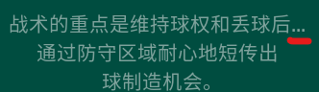
- For this issue, you can insert a Zero-Width Space just after the last character appearing correctly in the game. In this example, we would insert the Zero-Width Space after ‘后’.
- You can find Zero-Width Space in Character Map app on Windows. Simply type in “200B” in ‘Go to Unicode:’ to find the character.
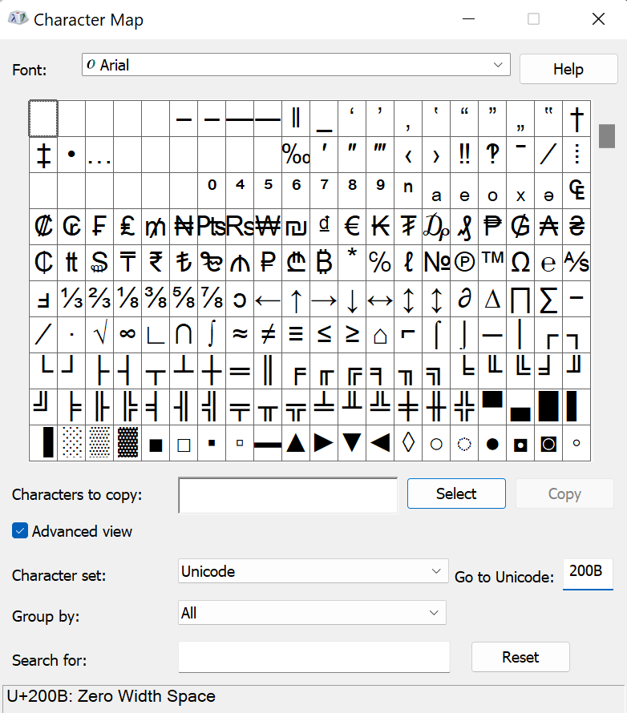

ADD NEW STRINGS TO THE EXISTING LTF FILE

- In some circumstances, we might add new strings in an update to improve the gameplay experience.
- New strings will be added to the “example.ltf” file in C:\Users\[Your Username]\Documents\Sports Interactive\Football Manager 2023\languages
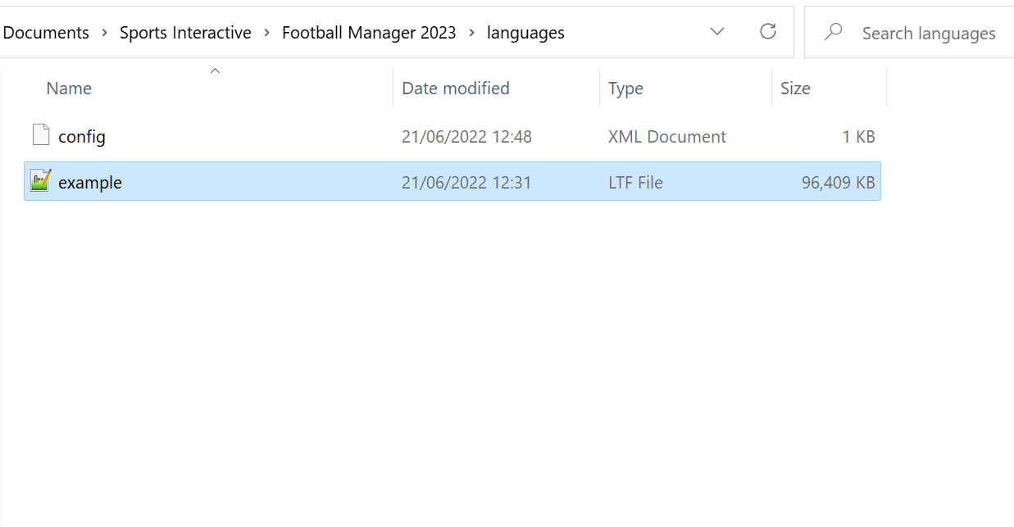
- You can simply open the “example.ltf” and copy and paste the new strings to your main LTF file and begin localising as usual.

TRANSLATING ENTITIES USING THE FOOTBALL MANAGER 2023 EDITOR

- The LTF file gives you access to every string in Football Manager but the names of the “entities” within the Football Manager database (agreements, awards, clubs, cities, competitions, continents, currencies, derbies, descriptions, injuries, languages, local regions, media sources, nations, people, stadiums, stage names and weather etc.) can only be edited using the Football Manager 2023 Editor, a powerful standalone tool that allows users to make changes to the database that will appear in-game.
- To create simple translations for entities using the Football Manager 2023 Editor simply replace existing entity names and other required fields with your desired translation.
- At present the Editor does not support entity genders so, if your target language makes use of multiple genders for things like Clubs, Nations, Continents, Competitions etc., be aware that your translation options will be limited.
- Once you’ve made some translations using the Editor save your file using the .fmf format (making sure to save it to C:\Users\[YOURUSERNAME]\Documents\Sports Interactive\Football Manager 2023\editor data) and use it when starting a new game within Football Manager 2023 by selecting “Career” > picking your translation .fmf file from the “Database” dropdown at the top right of the “Career Game Setup” page and then selecting “Advanced Setup”.

- Translating entities using the competitions editor is relatively straightforward. The basic steps to create a new community translation are as follows:
  - Open Steam (to use the Editor you must have a working version of Football Manager 2023 in your library)
  - From the Main Menu bar select “LIBRARY” then “TOOLS” from the drop down

  - Find “Football Manager 2023 Editor” in the list of tools that appear, right click on it and select “Install Game” from the popup. This will install the Editor on your machine.



  - Once the Editor is installed launch it by double clicking on it or right-clicking and selecting “Play Game” from the popup

  - The Editor will launch in a new window and load a database
  - To create translations first make sure that “Database” is selected in the “Menu” panel at the top left of the Editor

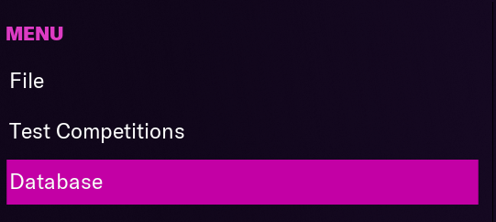

  - Then simply find the entity you wish to translate. First select the area which the entity you wish to translate is categorised as (for example to translate the club “Watford” select “Clubs”)
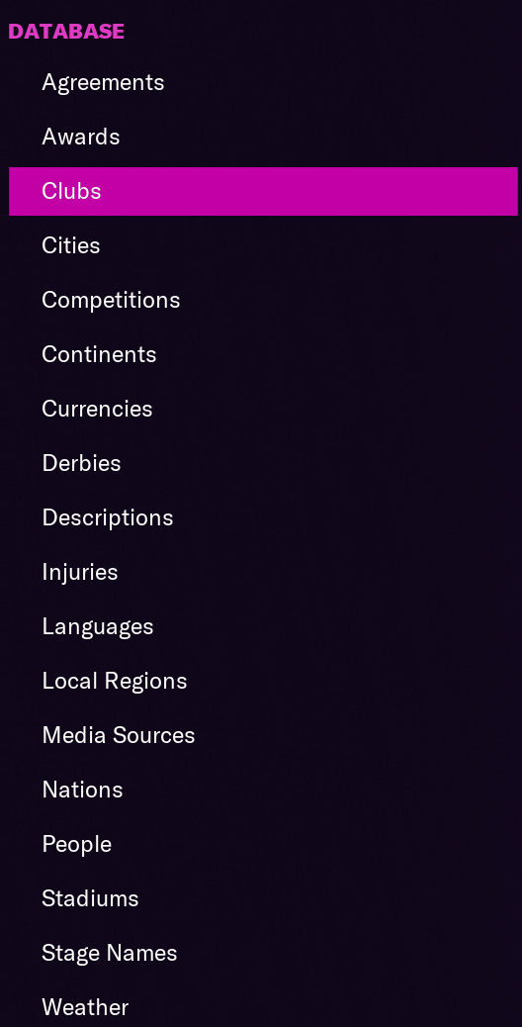

  - Then use the “Edit Filter” panel to search for whatever you’re looking for by selecting “Add Condition” to pick from multiple searchable fields. In this example we’ll use “Name” and search for “Everton” (though you could filter by any of the provided fields: Nation, Competition etc.) Search results are displayed in the panel below the filter.
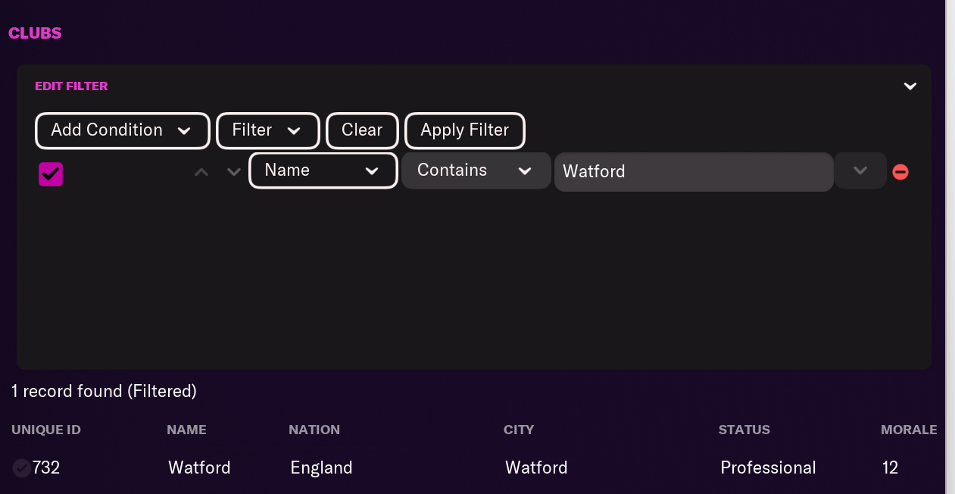
  - Select the entity you wish to edit by either double clicking it or selecting it and clicking the “Edit” button below the search results. This will take you to the entity’s unique page where translations can be made.
  - To make a translation simply select the text you wish to translate and replace it with a translation in your target language

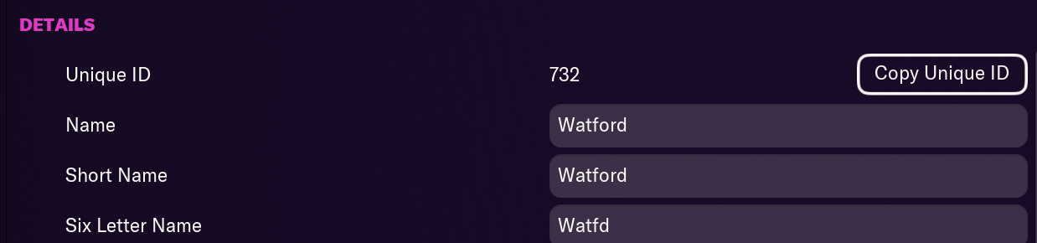

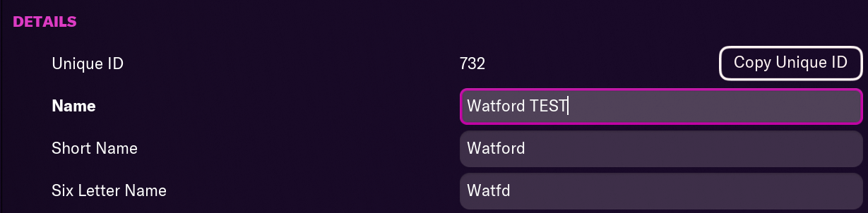

  - Then simply repeat this step for any other text/entities you wish to translate
  - If you would prefer not to filter for specific entities and simply see every record within a specific area, if for example you wish to translate every Nation in the database, you can do so by simply clicking on Nation and all entities will appear by default.

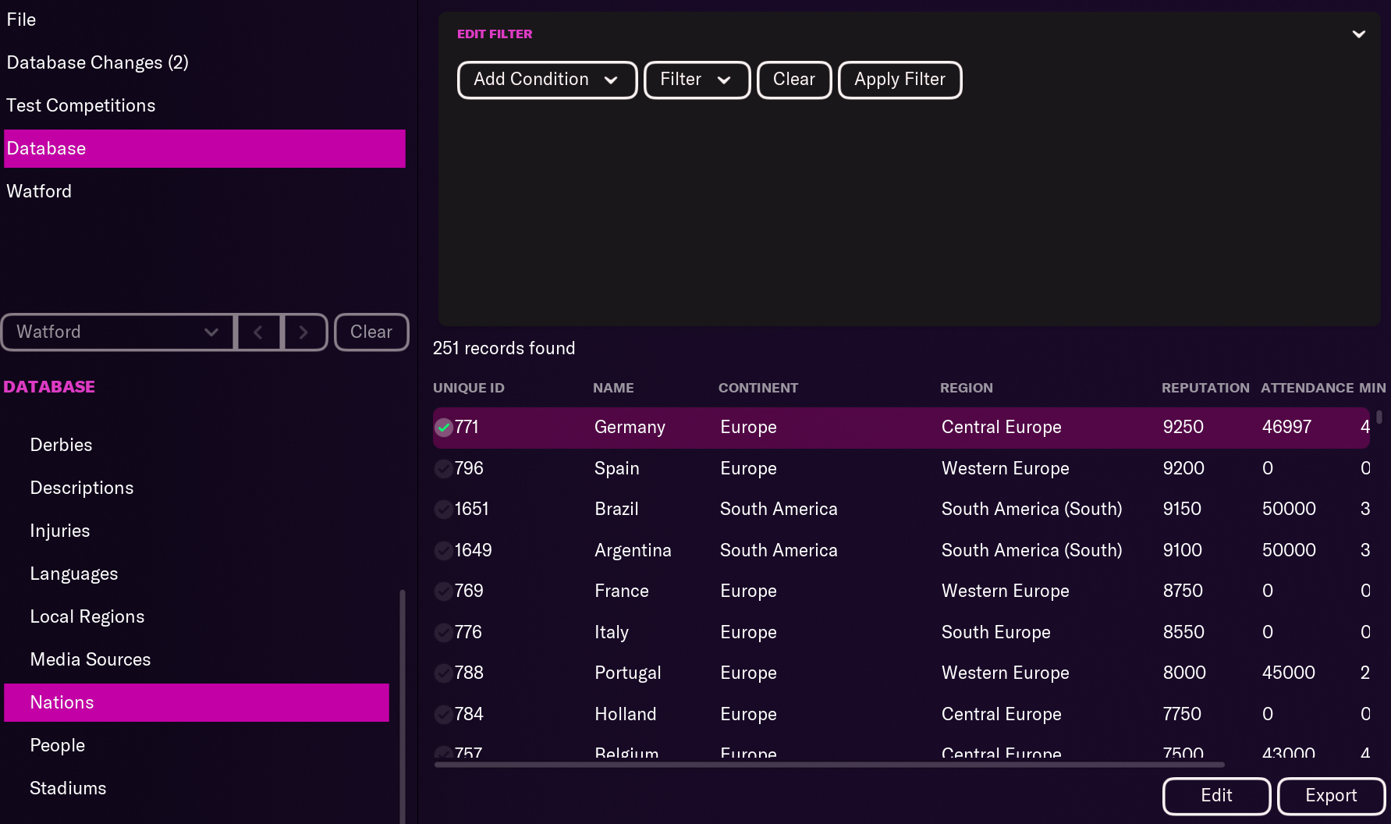
  - To save an edited file select “File > Save Editor Data As…” (making sure that the “Use FMF format” option is ticked), enter a name for your FMF file and save to the “C:\Users\[YOURUSERNAME]\Documents\Sports Interactive\Football Manager 2023\editor data” folder.

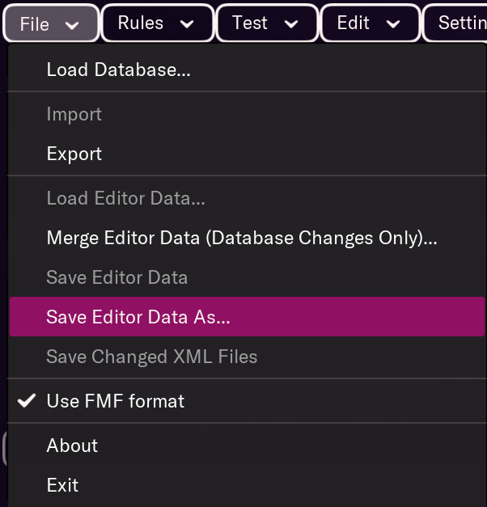

  - To use your new FMF file in-game first make sure it has been saved to the “C:\Users\[YOURUSERNAME]\Documents\Sports Interactive\Football Manager 2023\editor data” folder.
  - Then open Football Manager 2023 and select “Start New A Game” > “Career”



  - In the resulting “Career Game Setup” screen make sure your new FMF file is selected in the “Database” drop down at the top right of the screen. In the example below our Watford translation FMF has been saved as “Watford_Translation”.
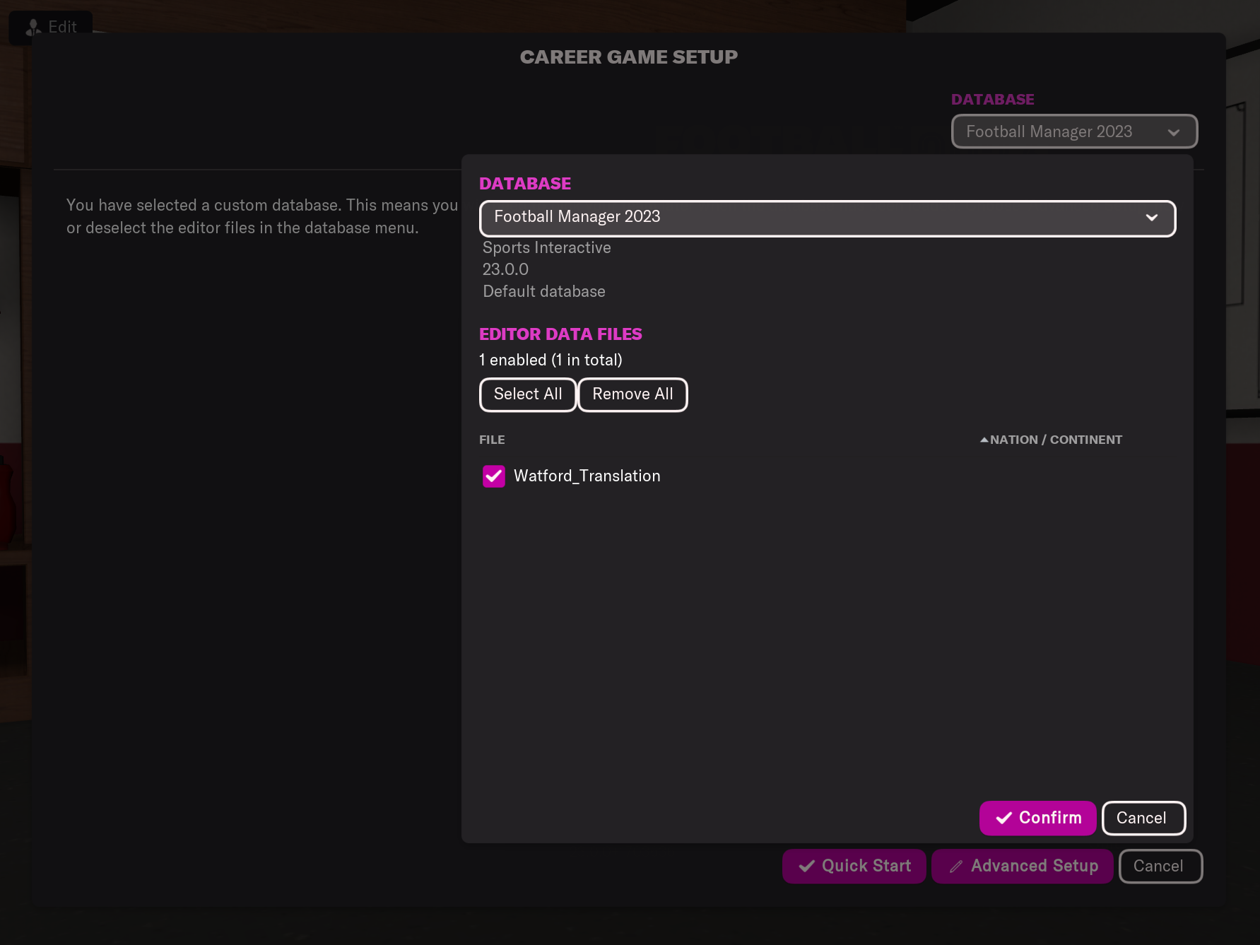
  - Then select “Advanced Setup” and create your game as normal. Once the game has been created any changes you made in the FMF file will appear.

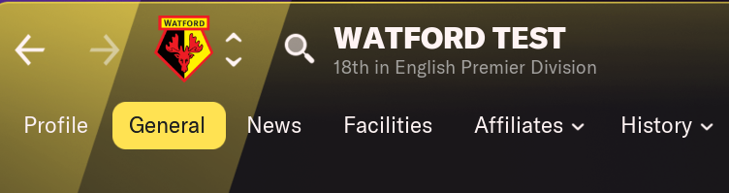

PUBLISHING FMF TRANSLATIONS TO STEAM WORKSHOP

- To publish your FMF translation to Steam Workshop open up the Football Manager 2023 Editor and load the file you want to publish by navigating to “File > Load Editor Data…” (making sure that the “Use FMF format” option is ticked) and selecting your translation FMF in the “Load” popup.

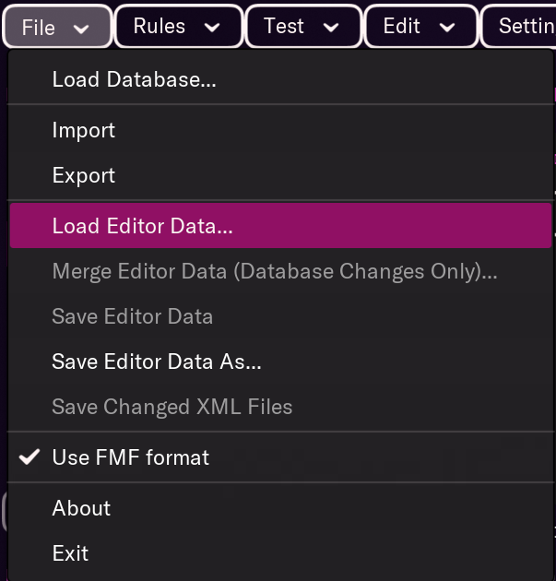

- Then navigate to “File > Save Editor Data As…” (making sure that the “Use FMF format” option is ticked)

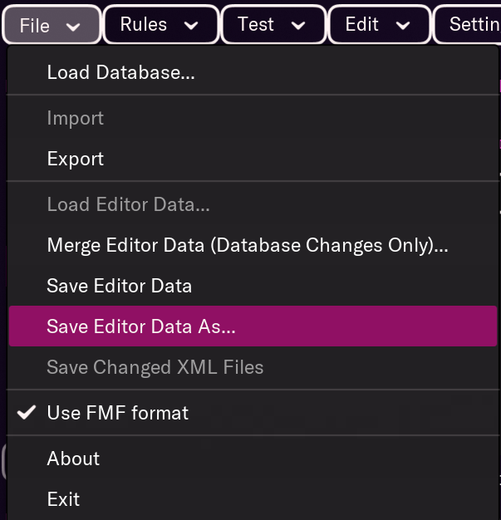

- In the resulting popup select “Publish to Steam Workshop”, making sure the dropdown is set to “Public” if you wish to share it publicly, “Friends Only” if you wish to only share it with Steam Friends or “Hidden” if you don’t wish it to be viewable.
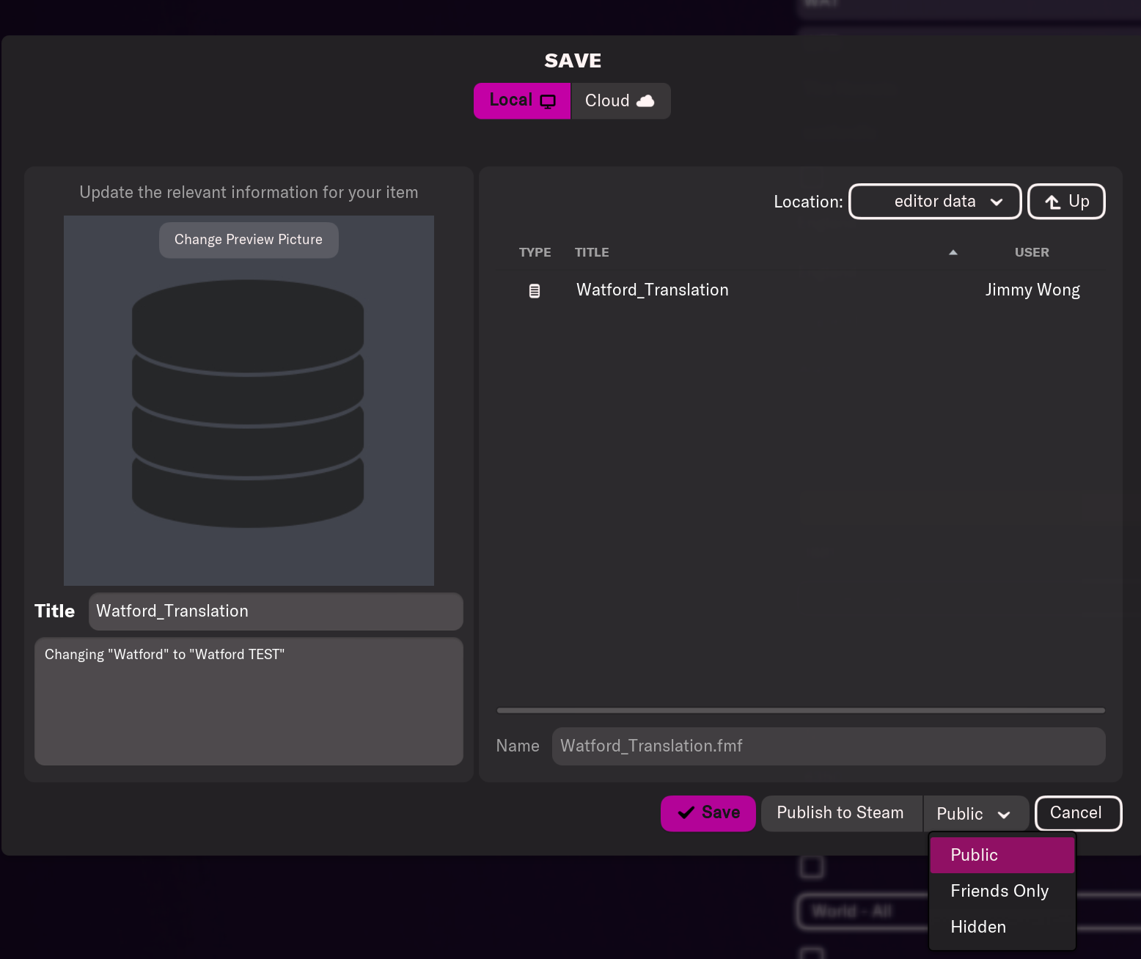

- This will automatically upload your FMF to Steam Workshop so be sure to give it an appropriate title, description and Preview Picture (all entered in the above window).

- Finally make sure you’ve saved the master version so you can continue to make changes and updates to your entity translation.

www.sigames.com / www.community.sigames.com

